**West Coast Collaborative**

Mathematics Specialist Unit 4

Test 4 2018: Calculus

**Student Name:** _____________________________

**Section One – calculator-free section**

**Time allowed for this task:** 30 minutes, in class, under test conditions

**Materials Provided:** SCSA Formula Sheet

**Materials required:** (to be provided by the student)

Standard items: Pens (blue/black preferred), pencils (including coloured), sharpener, correction fluid/tape, eraser, ruler, highlighters.

All electronic devices switched off and in bags.

**Marks available:** 31 marks

**1. [2, 3, 4, 4 = 13 marks]**

Determine the following definite integrals; using a judicious substitution, if necessary.

$\int{\frac{4x+10 }{x^{2}+5x+4}}$ $dx$

2. $\int{\frac{sin⁡(lnx)}{x}}$ $dx$ using the substitution, $u=\ln{x}$
3. $\int{\frac{2}{16+x^{2}}}$ d $x$ using the substitution, $x$ = 4 tan u
4. $\int{\frac{3x-1}{{(3x-4)}^{2}}}$ d $x$

**2. [4, 5, 5 = 14 marks]**

Evaluate

(a) $\int_{0}^{3}{\frac{1}{\sqrt{9- x^{2}}}} dx$ using the trig substitution x = 3 sin θ

(b) $\int_{0}^{4}{\frac{1}{9 - \sqrt{x}} dx}$ using the substitution u = $9- \sqrt{x}$

(c) $\int_{1}^{4}{\frac{x}{\sqrt{5-x}} }$ $dx$

**3. [4 marks]**

The graph below shows the function $y=\sin^{2}\left(\frac{x}{6}\right)$. Determine the area of the region trapped between

the function $y=\sin^{2}\left(\frac{x}{6}\right)$, the lines $x=-\frac{π}{2}$, $x=\frac{π}{2}$ and



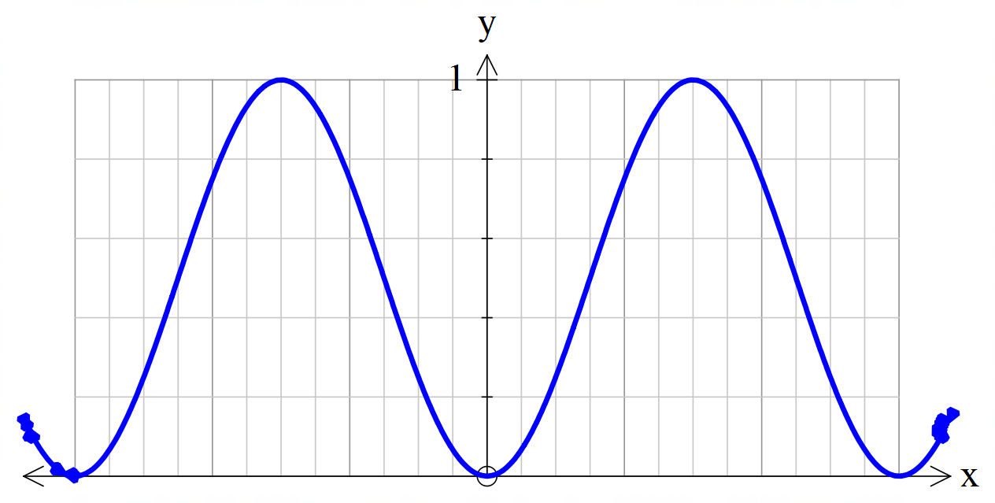

**End of Section One**

**This page has intentionally been left blank**

You may use this space to extend or re-attempt an answer to a question or questions and should you do so then number the question(s) attempted and cross out any previous unwanted working.

**West Coast Collaborative**

Mathematics Specialist Unit 4

Test 4: Calculus

**Student Name:** _____________________________

**Section Two – calculator-assumed section**

**Time allowed for this task:** 25 minutes, in class, under test conditions

**Materials Provided:** SCSA Formula Sheet

**Materials required:** (to be provided by the student)

Standard items: Pens (blue/black preferred), pencils (including coloured), sharpener, correction fluid/tape, eraser, ruler, highlighters.

Notes on one unfolded sheet of A4 paper.

Special items: Drawing instruments, templates, and up to three calculators approved for use in WACE examinations.

All other electronic devices must be switched off and stored in bags.

**Marks available:** 23 marks

**4.** **[4, 4 = 8 marks]**

For the curves with equations

3y2 = 16x and y2 = 64 - 16x,

determine:

(a) the area of the region enclosed between the two curves,

{b) the volume of the solid of revolution about the x-axis formed by this region

**5. [6 marks]**

Below is shown the cross-section of a river (see shaded), the bed of which is described by curves; f(x) = –10ln( $0.1x$ + 0.8) and g($x$) = 2.5 $e^{(0.1x+0.8)}$– 10, where $x$ and y are in metres. If Karan is located at P, gazing into the river, contemplating the meaning of life, and the river current is 2m/s then how many kilolitres (to the nearest kL) of water will pass him by in five minutes of his thinking?

Note: 1 m3 = 1kL

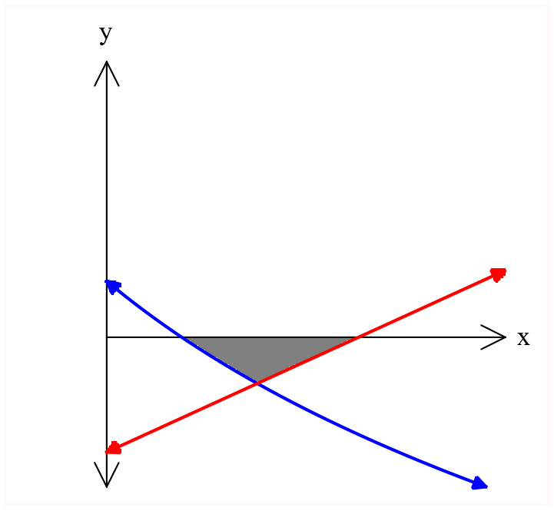

(a, b)

Q

P

$$x$$

*y*

**6. [3 marks]**

Below is shown the graph of the curve of y = 10ln(x–3) where both x and y are in centimetres.

A vase is to be created by rotating the curve about the y-axis from y = -20 to y = 10

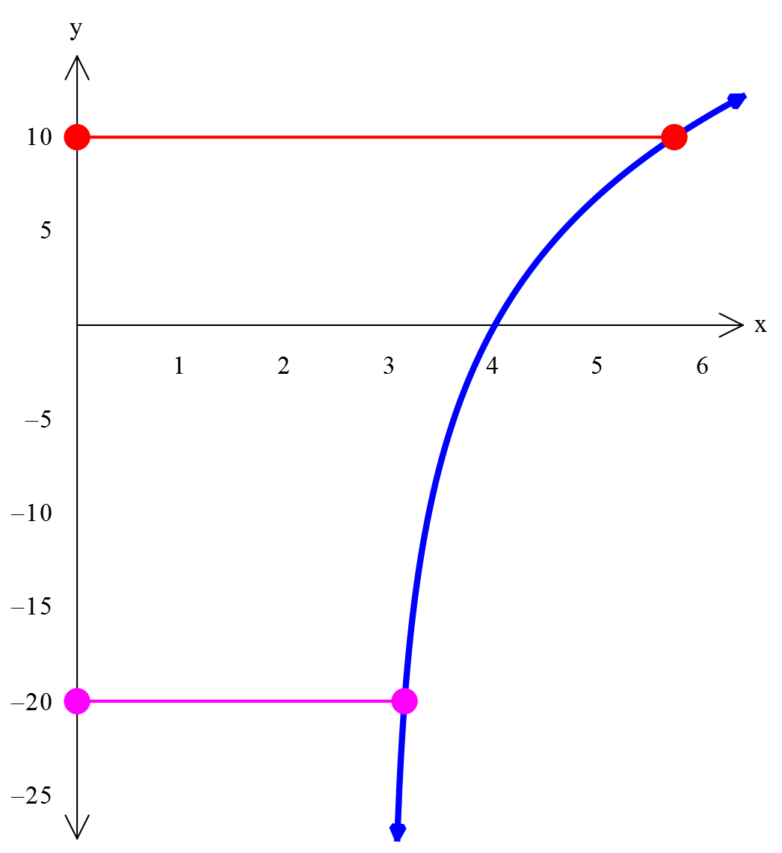

Determine the *volume* of the vase, correct to the nearest cm3.

**7. [6 marks]**

The region define by  for  is rotated about theaxis to generate and then rotated about the y axis to generate 

Prove that 

**End of Section Two**

**This page has intentionally been left blank**

You may use this space to extend or re-attempt an answer to a question or questions and should you do so then number the question(s) attempted and cross out any previous unwanted working.